Philadelphia University  Lecturer: Mr. Abdalrahman Obidat  Coordinator: Mr. Abdalrahman Obidat  Internal Examiner: Dr. Mohammad Taye |  | Faculty of IT  Department of SE  Examination Paper

Computer Aided Software Engineering (721445+722489) Section 1 First Exam

First Semester of 2011/2012 Date: 14/11/2011 -------- Time: 1 hour

Student Name: Student #:

Information for Candidates
- This examination paper contains 5 questions on 3 pages totaling (20) marks.
- The marks of questions are shown in round brackets. (-- marks).
Advice to Candidates
1- You should attempt all questions.
2- You should write your answers clearly.

I. Basic Notions
Objectives: The aim of the questions in this part is to evaluate the required minimal student knowledge and skills. Answers in the pass category represent the minimum acceptable standard.

Question 1: Knowing that CASE is stand for Computer Aided Software engineering, answer the following: (3 marks)
- What is CASE? —1.5 marks
Software systems that are intended to provide automated support for software process activities.

Give three of CASE tools Taxonomy? —1.5 marks
Project management
Support
Analysis and Design
Programming
Integration and Testing
Prototyping
Maintenance)

II. Familiar Problems Solving
Objectives: The aim of the questions in this part is to evaluate that have some basic knowledge of the key aspects of the lecture material and can attempt to solve familiar problems.

Question 2: In Microsoft Project If we have two tasks A and B: (5 marks)
A) What is the relationship between A and B in the following figure? Find the value of lag time if task A length is 8 hours? —2 marks

50%

Relation ship is Finish-to start (FS)
Lag time = - 4 hours

B) If the relationship between tasks A and B is Start to finish. Draw this relationship with lag time = 0. —2 marks
C) In the following figure which part is called total slack for task A: 1 or 2 or 3?
—1 mark
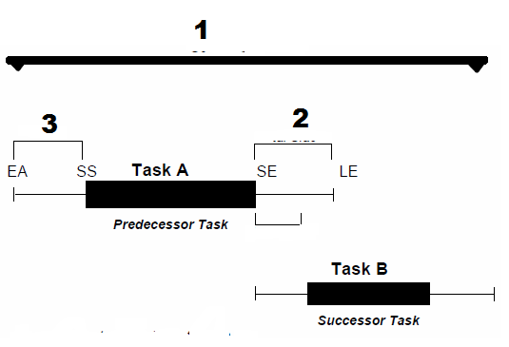
2
Question 3: Give an advantage of the following case tools: (2 marks)
- Requirement Tracing Tools —0.5 marks
making sure the contract is fulfilled and no requirements are accidentally missed

- Metrics Tools —0.5 marks
Evaluating quality of software under development and its functionality

- Project Planning Tools —0.5 marks
Planning of all the activities, resources, and estimation of materials and time scales.

- Dynamic analysis tools —0.5 marks
  - Interactions with an executing program
  - Provide information regarding number of times a loop is executed, running time of components, etc.

Question 4: In Leap SE Case tool: (4 marks)
A) There are three categories for requirement, what are these categories? —1.5 marks

B) Fill the following requirement using the Association template in following figure
"University library system shall provide appropriate viewers for the user to read documents in the document store." —3.5 marks

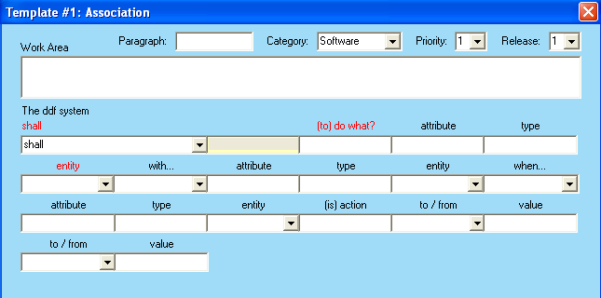

A)—1.5 marks
Functional requirements
Structural requirements
Technical requirements

B)—3.5 marks
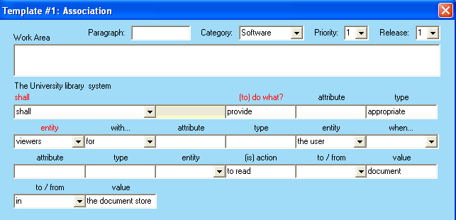

III. Unfamiliar Problems Solving
Objectives: The aim of the questions in this part is to evaluate that you can make progress towards the solution of unfamiliar problems, and can set out reasoning and explanation in a clear and coherent manner.

Question 5: Compare between CASE Tools Categories Upper-CASE and Lower-CASE, then determine which of them we need more and why? (4 marks)
- Upper-CASE
  - Tools to support the early process activities of requirements and design;
- Lower-CASE
  - Tools to support later activities such as programming, debugging and testing.

- We need Lower-CASE more than Upper-CASE since Upper-CASE activities is more complex to be done without using any case tools

